Creating an EKS Cluster Using Fargate

1 Introduction 3
2 Documentation Links 5
3 Setting Up a Kubernetes cluster (eks) using fargate 6
3.1 Installing eksctl 6
3.2 Installing kubectl 7
3.3 Creating the EKS Cluster 8
3.4 Validate Cluster created on AWS Console 9
4 Deleting/stopping EKS cluster 11
4.1 Deleting Fargate Profile 11
4.2 Deleting Cloudformation Stack 12
5 Summary 14

Introduction
EKS:
EKS (Elastic Kubernetes Service) is a managed Kubernetes service that allows you to run Kubernetes on AWS without the hassle of managing the Kubernetes control plane.
The Kubernetes control plane plays a crucial role in a Kubernetes deployment as it is responsible for how Kubernetes communicates with your cluster — starting and stopping new containers, scheduling containers, performing health checks, and many more management tasks.
The big benefit of EKS, and other similar hosted Kubernetes services, is taking away the operational burden involved in running this control plane. You deploy cluster worker nodes using defined AMIs and with the help of CloudFormation, and EKS will provision, scale and manage the Kubernetes control plane for you to ensure high availability, security and scalability.

AWS Fargate:
AWS Fargate is a serverless compute engine for containers that works with both Amazon Elastic Container Service (ECS) and Amazon Elastic Kubernetes Service (EKS). Fargate makes it easy for you to focus on building your applications. Fargate removes the need to provision and manage servers, lets you specify and pay for resources per application, and improves security through application isolation by design.
Fargate allocates the right amount of compute, eliminating the need to choose instances and scale cluster capacity. You only pay for the resources required to run your containers, so there is no over-provisioning and paying for additional servers. Fargate runs each task or pod in its own kernel providing the tasks and pods their own isolated compute environment. This enables your application to have workload isolation and improved security by design.

This activity guide cover steps for:

  - Setting up AWS Kubernetes Cluster (EKS) using Fargate
    - Open Your Terminal
    - Configure AWS CLI
    - Install and Configure eksctl
    - Move the extracted binary to /usr/local/bin
    - Install and Configure kubectl
    - Apply execute permissions to the binary
    - Create your EKS cluster using Fargate support
    - Validate if cluster is ready.
  - Deleting /Stopping EKS cluster
    - Navigate the Fargate-Profile and delete it first
    - Delete the my-cluster-demo (EKS cluster created)
    - Delete the Cloudformation Stacks

Documentation Links

- Installing the AWS CLI
https://docs.aws.amazon.com/cli/latest/userguide/cli-chap-install.html
- Installing eksctl
https://docs.aws.amazon.com/eks/latest/userguide/getting-started-eksctl.html
- Installing kubectl
https://docs.aws.amazon.com/eks/latest/userguide/install-kubectl.html
- What is AWS Fargate?
https://aws.amazon.com/fargate/
- Getting Started with AWS Fargate using Amazon EKS
https://docs.aws.amazon.com/eks/latest/userguide/fargate-getting-started.html/
- Basic Linux Commands
https://maker.pro/linux/tutorial/basic-linux-commands-for-beginners

Setting Up a Kubernetes cluster (eks) using fargate
1.Create Ubuntu 24.04 EC2 instance (t2 medium with all traffic allowd

2.Install and configure aws cli
sudo su -
apt-get update
apt install curl unzip
curl "https://awscli.amazonaws.com/awscli-exe-linux-x86_64.zip" -o "awscliv2.zip"
unzip awscliv2.zip
sudo ./aws/install

# aws --version

Open your terminal and check aws version using following command.
Configure your aws credentials
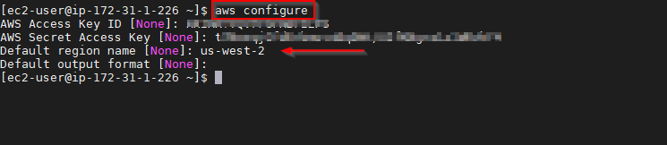

Installing eksctl

- Install and Configure eksctl by downloading and extracting latest its release
curl --silent --location "https://github.com/weaveworks/eksctl/releases/latest/download/eksctl_$(uname -s)_amd64.tar.gz" | tar xz -C /tmp

- Move the extracted binary to /usr/local/bin
sudo mv /tmp/eksctl /usr/local/bin

- Test the installation
eksctl version

Installing kubectl

- Download the Amazon EKS vended kubectl binary

curl -o kubectl https://amazon-eks.s3.us-west-2.amazonaws.com/1.17.9/2020-08-04/bin/linux/amd64/kubectl

- Apply execute permissions to the binary
chmod +x ./kubectl

- Move the kubectl to a folder that is in your path
sudo mv ./kubectl /usr/local/bin
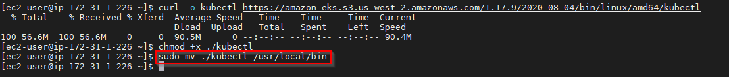
- Test the installation
kubectl version --short --client
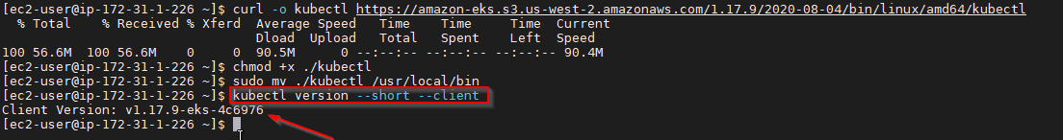

Creating the EKS Cluster
- Create an EKS cluster using Fargate Support
eksctl create cluster --name my-cluster-demo --version 1.34 --region us-east-1 --fargate
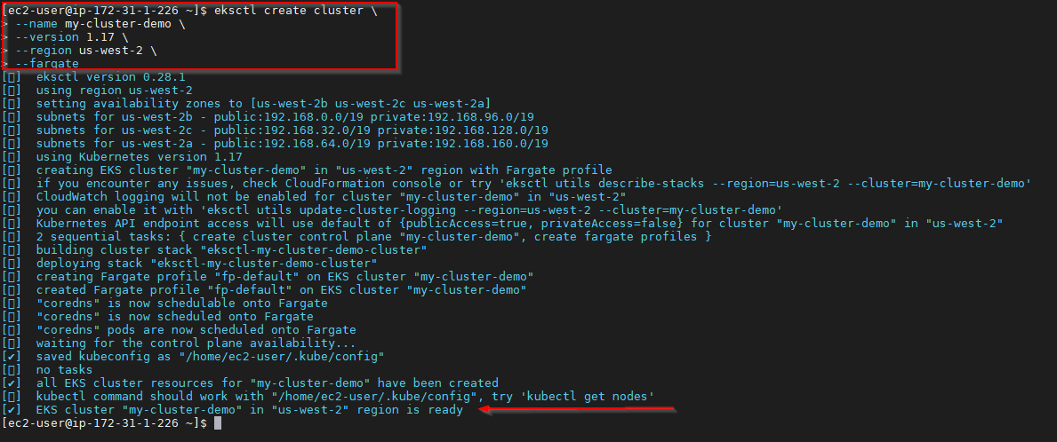
Note: It would take 10-15 minutes for the cluster to be created

- Validate if the cluster is ready
kubectl get svc

Validate Cluster created on AWS Console
- Open AWS Console and Click on EKS
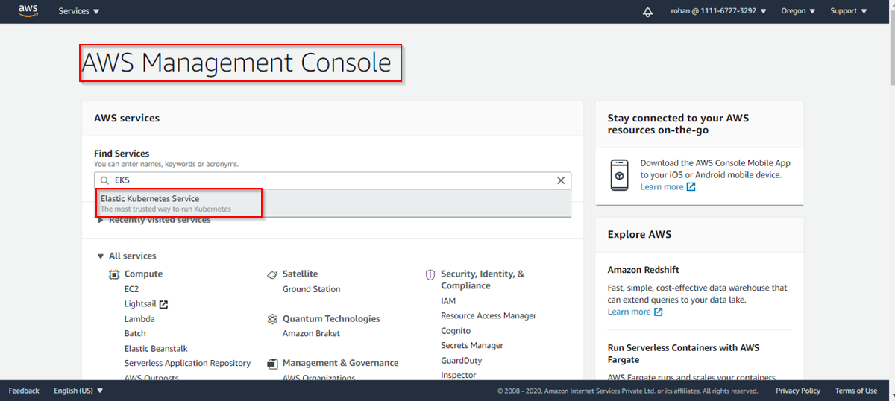

- Cluster created successfully
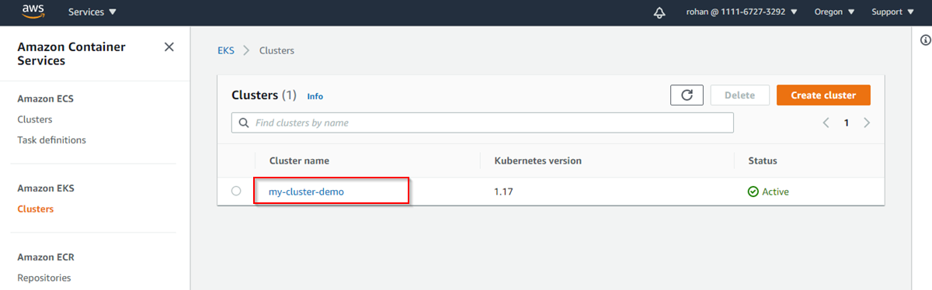

- Cloudformation stack created
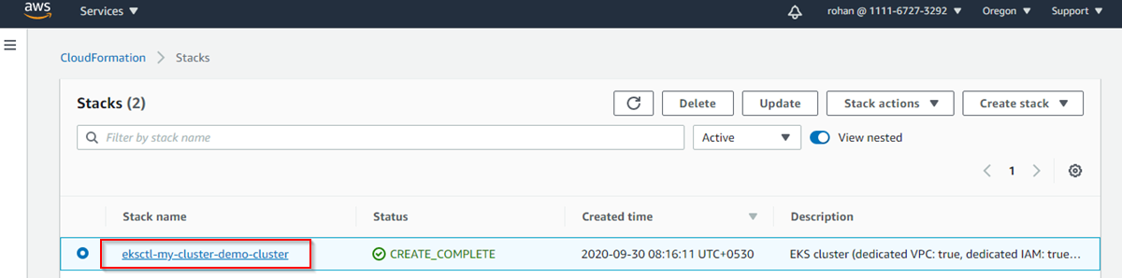

- Cloudformation stack Template
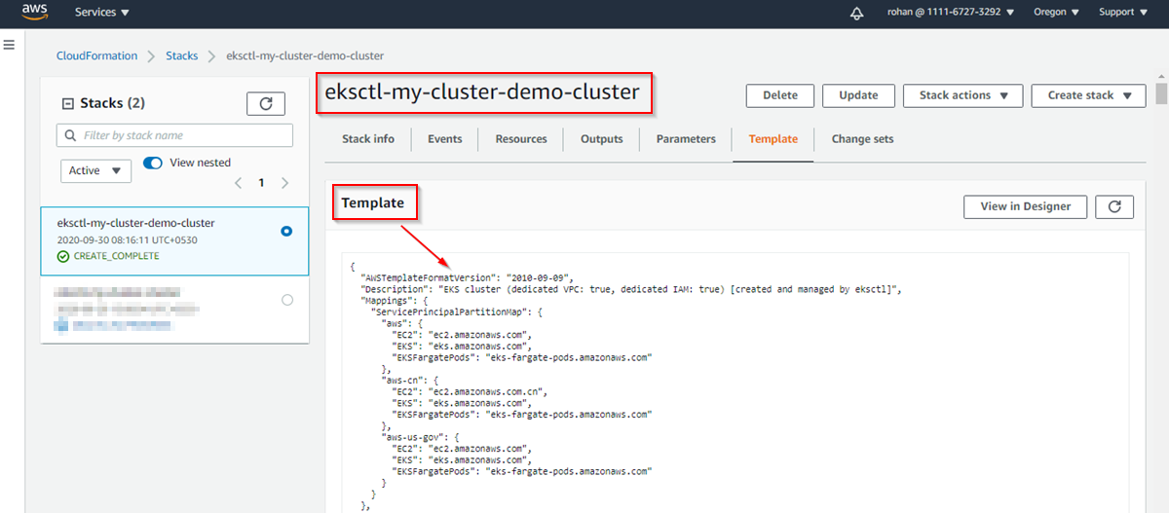

- IAM Roles Created by Cloudformation
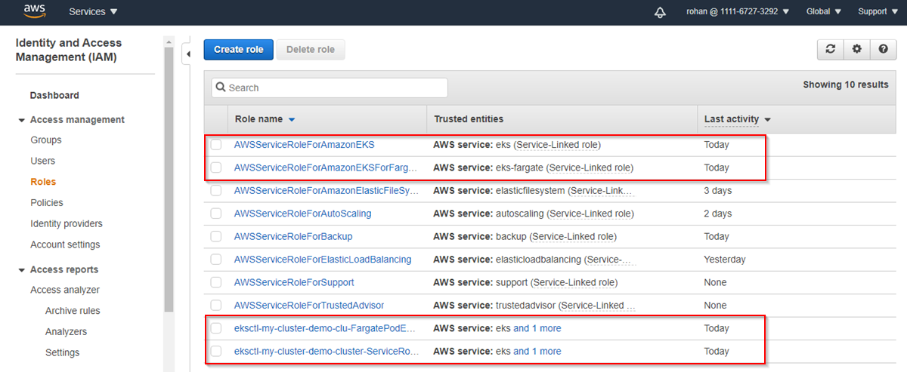

Deleting/stopping EKS cluster

Deleting Fargate Profile

- On EKS console Click on Compute.
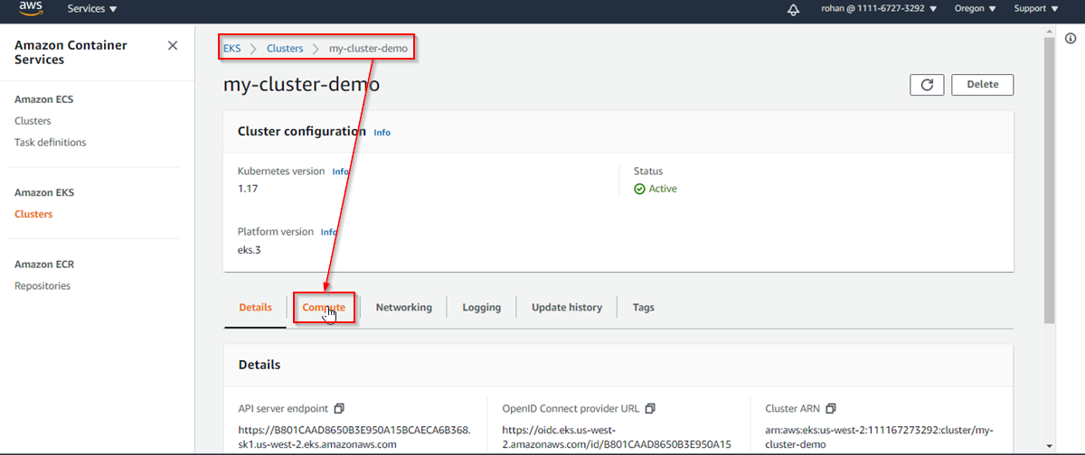

- Under Compute click on fp-default Fargate profile
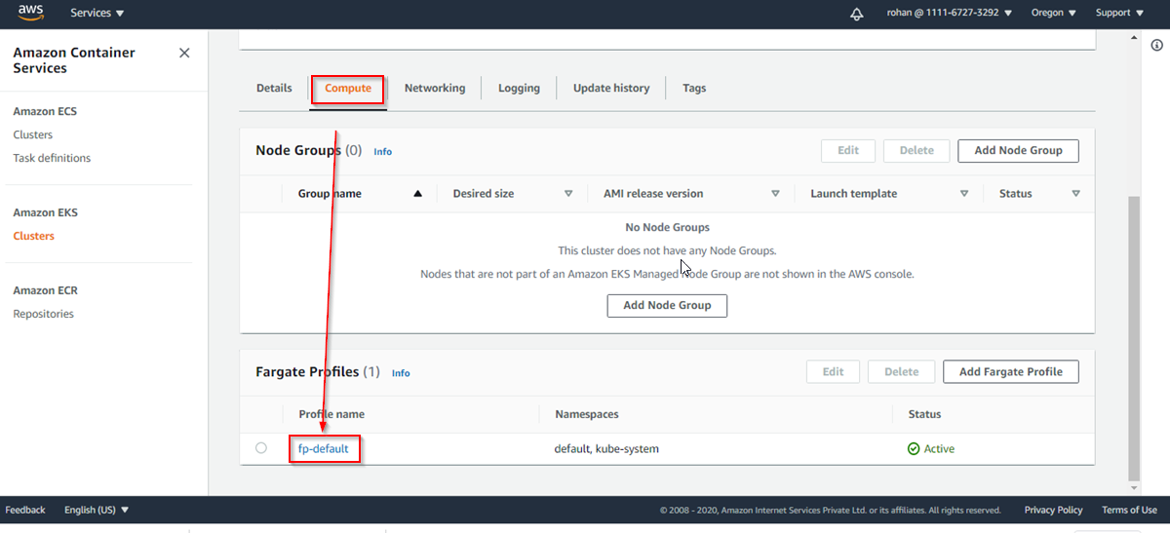

- On fp-default fargate profile Click on delete.
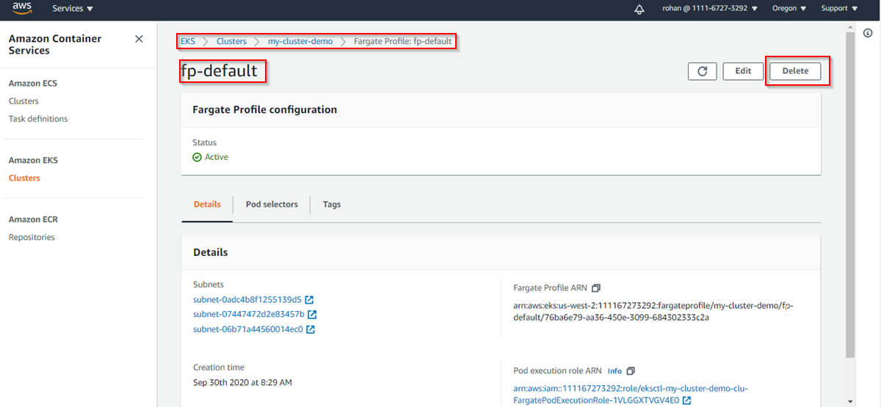

- To confirm deletion type fp-default and then Click on delete.
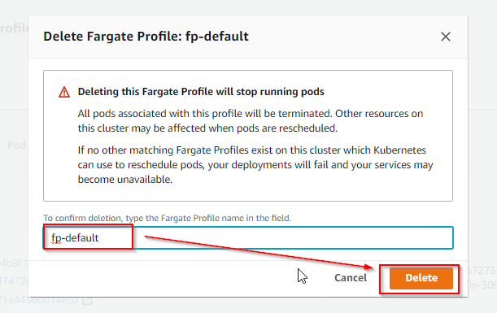

Deleting Cloudformation Stack

- Back on eks-cluster under cloudformation stack Click on delete.
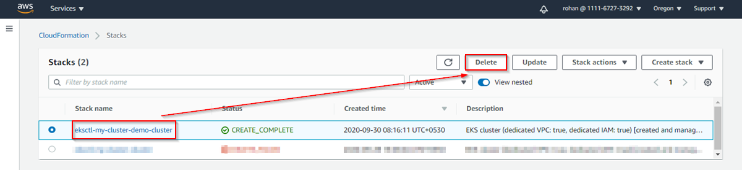

- Now Click on Delete stack.
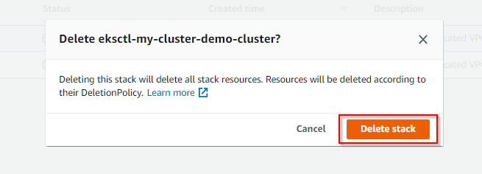

Ref: eksctl with nodegroup

The eksctl create nodegroup command is used to add a new managed or self-managed node group to an existing EKS cluster. Here’s a basic example for creating a managed node group:

eksctl create nodegroup \
--cluster my-cluster \
--name my-nodegroup \
--node-type t3.medium \
--nodes 2 \
--nodes-min 1 \
--nodes-max 3 \
--region ap-south-1

- Explanation:
- --cluster: Name of the EKS cluster to add the node group to.
- --name: Name for the node group.
- --node-type: EC2 instance type.
- --nodes: Desired number of nodes.
- --nodes-min & --nodes-max: Min/max autoscaling limits.
- --region: AWS region of the cluster.
- Optional Flags:
- --managed: (default is managed now) Explicitly create a managed node group.
- --ssh-access and --ssh-public-key: Allow SSH access using a specified key.
- --asg-access: Attach IAM policies for Auto Scaling group access.
- --tags: Add custom tags to the resources.

Creating eks cluster command using

eksctl create cluster \
--name my-cluster \
--region us-west-2 \
--nodegroup-name standard-workers \
--node-type t3.medium \
--nodes 2 \
--nodes-min 1 \
--nodes-max 3 \
--managed
- Breakdown:
- --name: Name of the EKS cluster.
- --region: AWS region to create the cluster in.
- --nodegroup-name: Name for the initial node group.
- --node-type: EC2 instance type for worker nodes.
- --nodes: Number of nodes to start with.
- --nodes-min and --nodes-max: Set autoscaling limits.
- --managed: Create a managed node group (recommended).
- Optional flags:
- --version: Specify Kubernetes version.
- --vpc-private-subnets and --vpc-public-subnets: Use custom VPC subnets.
- --tags: Add tags to cluster and nodegroup resources.
- --ssh-access and --ssh-public-key: Enable SSH access to nodes.

Summary

This activity guide cover steps for:

    - Setting up AWS Kubernetes Cluster (EKS) using Fargate
    - Open Your Terminal
    - Configure AWS CLI
    - Install and Configure eksctl
    - Move the extracted binary to /usr/local/bin
    - Install and Configure kubectl
    - Apply execute permissions to the binary
    - Create your EKS cluster using Fargate support
    - Validate if cluster is ready.
    - Deleting /Stopping EKS cluster
    - Navigate the Fargate-Profile and delete it first
    - Delete the my-cluster-demo (EKS cluster created)
    - Delete the Cloudformation Stacks

